Change Order Request

May 20, 2016

Chinn Construction, LLC
14715 NE 95th Street, Suite 101
Redmond, WA 98052
Attn: Charlie Poggemann

Re: Hadley Apartment Project – Change Order Request – Retail Plaza Trench Drains

Charlie,

Per your request, see options below for the trench drains at the east retail plaza trench drains. Please let me know which options we are to proceed with. Let me know if you have any questions or comments. Thanks.

Cost to install ~152LF of Zurn Z886 zero-slope trench drain as highlighted in red attached is $16,516 + 10% OH&P = $18,168. This includes Zurn –HPD heel-proof ductile slotted grate – class B.

Cost to install sleeves through the retaining walls for the piping that goes to the trench drains is $884 + 10% = $972.

Cost to install underground piping from trench drains through retaining walls to allow for connection by civil contractor at sidewalk, as highlighted in green attached, is $2,477 + 10% OH&P = $2,724.

TOTAL AMOUNT OF THIS COR = $21,864

All concrete work, excavation, backfill, bedding, fine grading, spoils disposal, fill materials, waterproofing is excluded.

Sincerely,
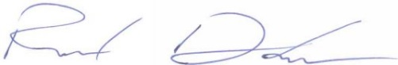
Richard Donelson
Project Manager / Estimator
richd@owpllc.net
425-591-4296 cell

